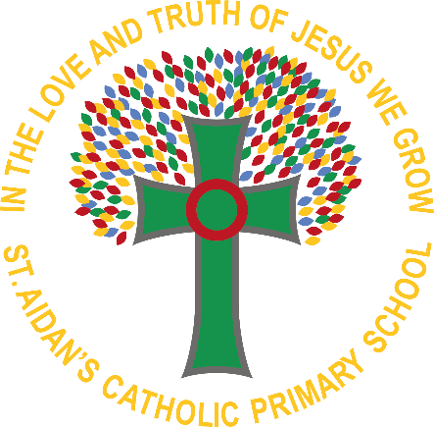
St. Aidan’s Catholic Primary School
Curriculum Summary
YEAR 4

SUBJECT | AUTUMN TERM |  | SRPING TERM |  | SUMMER TERM
Maths | Place Value  Addition and Subtraction  Measurement (Area)  Multiplication and Division |  | Multiplication and Division  Length and Perimeter  Fractions  Decimals |  | Decimals  Money  Time  Shape  Statistics  Position and direction
Literacy | Writing genres:  Poetry- Rhyme  Place value of punctuation and grammar  Biography: Black History Month  Narrative: Book based on diversity  Instructions: Linked to history  Christmas Narrative: One Christmas wish |  | Writing genres:  Narrative: Setting descriptions  Report writing: Boudicca  Author Study: International Women’s Day  Explanation Texts: How does sound work |  | Writing genres:  Persuasive Texts: water pollution  Narrative: tales from other cultures  Letter: Aspiration week- To aspirational person  Poetry: Beauty of our world
RE | PEOPLE - The family of God in Scripture  CALLED - Confirmation: a call to witness  JUDAISM- Torah  GIFT - God’s gift of love and friendship in Jesus |  | COMMUNITY - Life in the local Christian community and ministries in the parish  ISLAM – Qur’an  GIVING & RECEIVING - Living in communion  SELF DISCIPLINE - Celebrating growth to new life |  | NEW LIFE - To hear and live the Easter message  BUILDING BRIDGES - Admitting wrong, being reconciled with God and each other.  GOD’S PEOPLE - Different saints show people what God is like.
Science | States of matter  Compare and group materials together, according to whether they are solids, liquids or gases  Observe that some materials change state when they are heated or cooled, and measure or research the temperature at which this happens in degrees Celsius (°C)  Identify the part played by evaporation and condensation in the water cycle and associate the rate of evaporation with temperature | Electricity  Identify common appliances that run on electricity  Construct a simple series electrical circuit, identifying and naming its basic parts, including cells, wires, bulbs, switches and buzzers  Identify whether or not a lamp will light in a simple series circuit, based on whether or not the lamp is part of a complete loop with a battery  Recognise that a switch opens and closes a circuit and associate this with whether or not a lamp lights in a simple series circuit  Recognise some common conductors and insulators, and associate metals with being good conductors | Animals including humans  Describe the simple functions of the basic parts of the digestive system in humans  Identify the different types of teeth in humans and their simple functions  Construct and interpret a variety of food chains, identifying producers, predators and prey | Sound  Identify how sounds are made, associating some of them with something vibrating  Recognise that vibrations from sounds travel through a medium to the ear  Find patterns between the pitch of a sound and features of the object that produced it  Find patterns between the volume of a sound and the strength of the vibrations that produced it  Recognise that sounds get fainter as the distance from the sound source increases | Living things  Recognise that living things can be grouped in a variety of ways  Explore and use classification keys to help group, identify and name a variety of living things in their local and wider environment  Recognise that environments can change and that this can sometimes pose dangers to living thing
Geography | Focus on Europe  -Where is Europe?  -What is it like in Spain?  -Comparing physical and human features of Spain to the UK |  | Resources and trade  - Food around the world  - Minerals around the world  - Who do we trade with?  - Trading in the future |  | Rivers and Mountains  - Mountain landscapes in the UK  - Features of mountain landscapes  - Long profile of the river  River landforms
History | Mayan Civilisation  -When did the Mayans live?  -Where did they live compared to other civilisations?  -Archaeology of Mayan cities  -What achievements did the Mayans have?  -How did the Mayans live?  -How was a Mayan city laid out?  -Assessment: What was it like to be a Mayan? |  | The Roman Empire  -The Empire  -What does the chronology of Roman Britain look like?  -How did the locals react to Roman invasion?  -What are the most significant Roman achievements?  -What is the legacy of Roman Britain?  -The end of Roman Britain  -Assessment: What did the Romans so for us? |  | Crime and Punishment  -Ordering key events  -Recap of time periods: research  -Crimes in Roman Britain  -Was Roman punishment fair?  -Compare and contrast modern Roman system to that of the Anglo Saxons.  -Crime in the Middle ages  -Crime in Tudor times  -The Victorian era of crime  -Crime and punishment in modern Britain  -Assessment: Has the punishment always fit the crime?
Art &  Design | Storytelling through drawing |  | Exploring Still Life |  | Festival Feasts
Design & Technology | Food – Healthy and Varied Diet  - The diet  - Eatwell guide  - Energy  - Nutrients – Macro and Micro  - Digestion  Making Activity – Crunchy chickpea sandwich |  | Textiles - 2D shape to 3D shape  - Design brief and task analysis  - Stitches skills  - Design specification and Design ideas  - Making – pattern cutting  - Making - embellishments  - Making - Assembly  Evaluation |  | Electronics – simple circuits and switches  - How does electricity work? Inputs/outputs  - How does a circuit work?  - Components  - Making  - Making  Testing and Evaluation
PSHE/RSE | Family and Relationships  Being Safe |  | Citizenship  Economic Wellbeing |  | Physical health & mental wellbeing  Careers and aspirations
Computing | COMPUTING SYSTEMS AND NETWORKS  The internet  Online Relationships (PSHE) | Privacy and security  Self-Image and identity (PSHE) | CODING AND COMPUTATIONAL THINKING  Coding  Online Reputation  Online Bullying (PSHE) | Managing online information  Copyright and ownership (PSHE) | INFORMATION TECHNOLOGY  Animation  Writing for different audiences  Health, wellbeing and lifestyle (PSHE)
Music |  | Christmas |  | Charanga |  | Charanga

