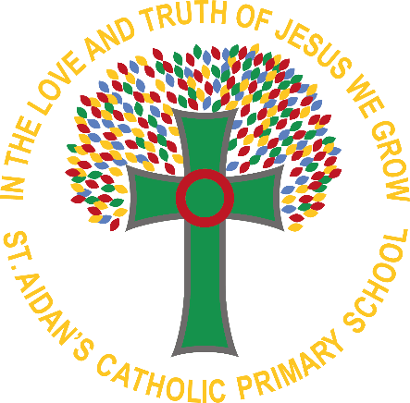
Come and See EYFS Overview of the Year 2024-2025

Week | Autumn 1 | Autumn 2 | Spring 1 | Spring 2 | Summer 1 | Summer 2
1 | Faith focuses | baptism and confirmation – Belonging | Local church – community | Eucharist - Relating | Pentecost—serving | Reconciliation—inter-relating
2 | Faith Focus | baptism and confirmation – Belonging | Local church – community | Eucharist - Relating | Pentecost—serving | Reconciliation—inter-relating
3 | Domestic church - family | JUDAISM | Local church – community | Lent/easter - giving | Pentecost—serving | Reconciliation—inter-relating *
4 | Domestic church - family | advent/Christmas - LovinG | Local church – community | Lent/easter - giving | Pentecost—serving | Universal church—world
5 | Domestic church - familY | advent/Christmas - Loving | ISLAM | Lent/easter - giving |  | Universal church—world
6 | Domestic church - family | advent/Christmas - Loving | Eucharist - Relating | Lent/easter - giving |  | Universal church—worlD
7 | baptism and confirmation – Belonging | advent/Christmas - LovinG | Eucharist - Relating |  |  | Universal church—world
8 | baptism and confirmation – Belonging

* due to thetiming of theTERMS There is only 3 weeks to complete this topic

on the next pages you will find teaching units, key vocabulary, big questions and assessement focuses for you to choose from.
Please note, other faiths units only have key vocabulary and no assessed pieces of work are needed. Thank you

Come and See EYFS AUTUMN TERM

AUTUMN TERM UNITS | Domestic church - family  Myself - God knows and loves each one | baptism and confirmation – Belonging  welcome - Baptism: a welcome to God’s family | advent/Christmas - waiting  Birthday - Looking forward to Jesus’ birthday
KEY VOCABULARY | myself,  name,  Christian,  family name,  precious,  parent,  God,  love,  loving parent,  prayer | Nursery:  welcome,  welcomed,  Baptism,  baptise,  water,  candle,  “In the name of …  Reception:  priest,  white garment,  godparents,  font  Sign of the cross | Nursery  birthday,  Christmas,  advent,  Jesus,  Mary,  Joseph,  swaddling clothes,  manger,  crib  Reception:  shepherds,  Wise Men,  wreath
BIG QUESTION | Why am I precious? | Why Is welcome important? | Why do we celebrate Birthdays?

JUDIASM KEY VOCABULARY | Nursery  Special days,  Jewish,  Hanukkah,  lamp, light,  Reception:  Menorah

Come and See EYFS SPRING TERM

SPRING TERM UNITS | Local church – special people  CELEbrating - People celebrate in Church | Eucharist – Relating - meals  gathering - Parish family gathers to celebrate Eucharist | Lent/easter – giving - change  growing - Looking forward to Easter
KEY VOCABULARY | Nursery:  church,  priest,  celebrate,  celebrating,  Parish family.  Reception:  Church,  family,  community, Temple,  parish | Nursery:  Welcome,  ‘The Lord be with you.. blessing,  bless  Reception:  Mass  Altar servers  Priest  Crucifix  Hymn books  Gathering hymn | Ash Wednesday,  Lent,  Easter,  new life  Grow,  spring,  different,  Lent,  Good Friday,  cross,  Easter Sunday  ‘grow inside’
BIG QUESTION | What and why do people celebrate? | Why do people gather together? | How and why do things grow?

ISLAM KEY VOCABULARY | Special object, precious prayer mat, book

Come and See EYFS SUMMER TERM

SUMMER TERM UNITS | Pentecost—serving- Holidays and Holydays  GOOD NEWS - Passing on the Good News of Jesus | Reconciliation—inter-relating - BEING SORRY  FRIENDS – Friends of Jesus | Universal church—world - NEIGHBOURS  Years OUR WORLD – God’s wonderful world
KEY VOCABULARY | Good News,  tell,  Pentecost,  promise,  Holy Spirit,  alleluia,  litany | Nursery:  friend,  happy,  sad,  love,  make  up,  kind,  gentle,  loving  sorry,  forgive,  change  Reception:  rule,  understanding,  new start,  friendship,  forgive,  change | world,  wonder,  wonderful,  care,  love,  share,  work / play together
BIG QUESTION | What is good news? | Is it good to have friends? | What makes our world so wonderful?

